Sale Return & Credit Wizard — User Manual
Oct 19, 2026 · @ibrahim

Overview
The Return / Credit wizard handles customer returns, cancellations and credit notes for a confirmed Sale Order from one popup, line by line. It decides which documents to create: a return receipt, a posted or draft credit note, or a reduction of what is still to deliver. Every run is recorded in a return log.
It is built for orders with many lines: you can search and filter the lines, then apply one action to all lines shown.
- Module: sale_return_wizard, Odoo 16, version 16.0.1.1.0
- Users: sales staff and sales managers handling returns, refunds and order changes

Access and prerequisites
You need the Returns & Credit Notes group to see the button. Sales Managers have it automatically.
To do this | You also need
Open the wizard, keep / cancel lines | Returns & Credit Notes group
Return goods (creates a return receipt) | Inventory / User
Get posted credit notes | Invoicing / Billing (or higher)
Read the return log | Sales / User: Own Documents Only (or higher)
An administrator grants the group in Settings › Users & Companies › Users, on the user's Access Rights tab (developer mode shows technical groups).
The button only appears when the Sale Order is in the Sales Order state (confirmed). It is hidden on quotations, cancelled orders and locked orders; unlock a locked order first.

Opening the wizard
Open the confirmed Sale Order and click Return / Credit in the header (shortcut: Alt+Shift+R). A popup opens titled Return / Credit: S0000x with every product line of the order. Section and note lines are not listed, and neither are down-payment lines.
The top right shows live counters: lines shown / total lines, how many lines are selected, and the estimated untaxed credit.
Column | Meaning
Product, SKU | Product and its internal reference
Ordered | Quantity on the order line
Delivered | Quantity delivered so far, net of earlier returns
Invoiced | Quantity invoiced, net of earlier credit notes
Returnable | Delivered quantity not yet returned
Undelivered | Ordered minus delivered: still waiting to ship
Creditable (hidden by default) | Invoiced quantity not yet credited
Action | What to do with this line (see Line actions)
Quantity | How much to return, credit or cancel
Max | The most this action allows on this line
To Credit | Quantity that will go on the credit note
Credit (untaxed) | To Credit × unit price after discount
All quantities are in the order line's unit of measure. Use the column picker at the right of the header row to show Description, Creditable or UoM.

Search, filter and bulk actions
The list filters itself as soon as you change a filter; you do not need to click anything. The search box applies when you press Enter or click away. Quantities you typed on a line are kept when the line is hidden, and they are still processed.
Filter | How to use it
Search | Matches product name, SKU, barcode or line description. Separate terms with commas to match any of them, e.g. FURN_8888, chair
Quantity between | Pick a quantity (Ordered, Delivered, Invoiced, Returnable, Undelivered). Alone, it shows lines where that quantity is above 0. Add min and/or max to narrow it; max 0 means no upper limit
Only Actionable | Hides lines with nothing to return, credit or cancel
Only Selected | Shows only lines whose action is not Keep and that have a quantity
Refresh re-runs the filter by hand. Reset clears every filter and shows all lines.
The buttons under the filters act only on the lines currently shown:
- Return all returnable: sets Return & Refund with the full returnable quantity
- Credit all invoiced: sets Credit Only with the full creditable quantity
- Cancel all undelivered: sets Cancel Undelivered with the full undelivered quantity
- Keep all: resets the shown lines to Keep
Lines where the action has no quantity available are skipped. Example: filter on FURN_, click Return all returnable, then clear the filter to review.

Line actions
Each line gets one action and one quantity. Pick the action first: the quantity fills in with the maximum, and you can lower it. Typing a quantity on a Keep line switches it to the first action that allows one.
Action | Use it when | Max quantity | What happens
Keep | Nothing changes on this line | 0 | Nothing
Return & Refund | The customer sends goods back and is refunded | Returnable | Return receipt; credit note for the part already invoiced; ordered qty lowered once goods arrive
Credit Only | Price allowance; customer keeps the goods (damaged, late, goodwill) | Creditable | Credit note only; no stock move; the line does not become invoiceable again
Cancel Undelivered | The customer no longer wants what has not shipped | Undelivered | Ordered qty lowered; pending delivery reduced or cancelled; over-invoiced part credited
A quantity can never be negative, above the ordered quantity, or above the action's Max. A return can never exceed what was delivered.
These limits are checked three times:
- While you type: a warning pops up and the quantity is set back to the maximum. Rows outside the limit turn red.
- When the popup saves: an invalid line blocks the save with a message naming the product.
- When you click Process: every line is re-checked against the order as it is now. If a colleague returned or invoiced part of the order meanwhile, you get an error instead of a double return.

Options and processing
Set the options under the table, then click Process and confirm.
Option | Default | Effect
Reason | empty | Becomes the credit note reference and appears in the return log, e.g. Damaged on arrival
Receive Returned Goods Now | on | Validates the return receipt immediately. Off: the receipt waits for the warehouse
Post Credit Notes | on | Posts the credit note for quantities on posted invoices. Off: everything goes to a draft credit note
Return Location | where goods were shipped from | Only with multiple locations enabled. Choose another internal location, e.g. a quarantine shelf
Even with Receive Returned Goods Now on, the return receipt is left open for the warehouse when it holds lot- or serial-tracked products, because someone must pick the lots.
Processing runs in this order: credit notes, then cancellations, then return receipts. When it finishes, the popup closes and the order's chatter gets a summary with a link to the return log.

What gets created
The wizard picks the documents from each line's delivery and invoice status; you never choose them by hand.
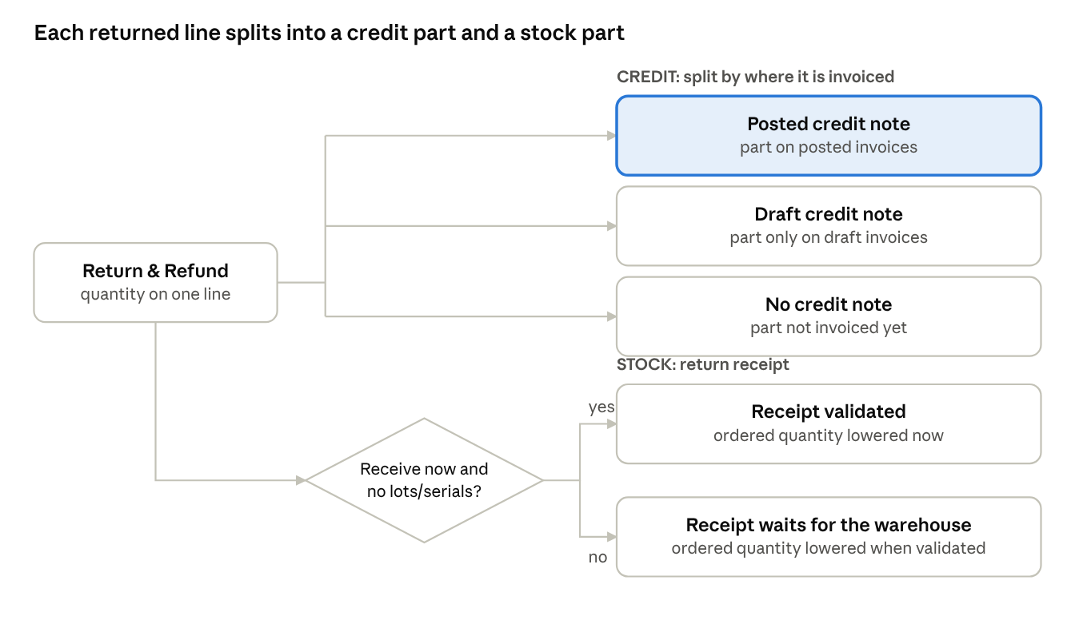
Return & Refund routing · credit part and stock part
A returned quantity is credited only up to what was invoiced: posted invoices first, then draft invoices. The rest only lowers what was delivered, so it is never billed.
Situation of the line | Documents created | Order line afterwards
Delivered and invoiced (posted), return 3 of 10 | Return receipt + posted credit note for 3 | 7 ordered, 7 delivered, 7 invoiced
Delivered, invoice still in draft, return 3 | Return receipt + draft credit note for 3 | Review and post the credit note together with the invoice
Delivered, not invoiced, return 4 of 10 | Return receipt only | 6 ordered, 6 delivered, 6 left to invoice
Delivered 10, invoiced 6, return 8 | Return receipt for 8 + credit note for 6 | 2 ordered, 2 delivered, 0 invoiced, 2 left to invoice
Partly delivered, Cancel Undelivered | Pending delivery reduced or cancelled; credit note only if invoiced in advance | Ordered = delivered
Credit Only | Credit note, not linked to the order line | Unchanged; nothing becomes invoiceable again
Credit note lines carry the order line's price, discount and taxes, so amounts are proportional. When the order has exactly one posted invoice, the credit note is linked to it as its reversal.

Return log
Every Process creates one return log record numbered SRET/YYYY/xxxxx. Find it from the Returns smart button on the Sale Order, or from Sales › Orders › Returns & Credits for all orders.
Where | What it shows
Header | Order, customer, reason, user, date, total credited, status
Status | Waiting Goods while a return receipt is open; Done once all are validated or cancelled
Smart buttons | The return receipts and credit notes this run created
Lines tab | Per product: action, quantity asked, quantity credited, quantity received back, ordered qty removed from the order, linked credit notes
The log list can be filtered by Waiting Goods or My Returns, searched by product, and grouped by customer or date. Logs cannot be created or edited by hand.

Examples
1. Damaged goods, already invoiced. Order of 10 Office Lamps, all delivered and on a posted invoice; 3 arrive broken.
- Click Return / Credit, search lamp.
- Set the lamp line to Return & Refund, quantity 3.
- Reason: Damaged on arrival. Keep both options on. Click Process.
Result: a validated return receipt for 3 lamps, a posted credit note for 3, and the order line becomes 7 ordered / 7 delivered / 7 invoiced.
2. Return before invoicing. Same order, not invoiced yet; the customer sends back 4. Set Return & Refund, quantity 4, and process. No credit note is created. The line becomes 6 ordered / 6 delivered, so the next invoice bills 6.
3. Customer drops the rest of a partial delivery. 3 meeting tables ordered, none shipped yet. Set Cancel Undelivered, quantity 3. The pending delivery is cancelled and the line drops to 0 ordered. If the tables were invoiced in advance, a credit note for 3 is created as well.
4. Goodwill discount. Delivery was late on 10 chairs that are invoiced; you agree to refund the value of 1 chair. Set Credit Only, quantity 1. A credit note for 1 chair is posted; stock and the order quantities do not change.
5. One run, many lines. Use filters and bulk buttons, then switch on Only Selected to review what will be processed before clicking Process. Example: filter on Undelivered, click Cancel all undelivered; filter on FURN_8888 and set Return & Refund 2; switch on Only Selected to check both, then process.

Troubleshooting and FAQ
Symptom or question | Cause and fix
No Return / Credit button | Order not confirmed or locked, or you lack the Returns & Credit Notes group
"Only confirmed sale orders" error | The order was locked or cancelled meanwhile; unlock it and reopen the wizard
"Set an action and a quantity on at least one line" | Every line is Keep or has quantity 0
"Exceeds the returnable / creditable / undelivered quantity" | The quantity is above Max, or the order changed since the popup opened; close and reopen the wizard
"You need Inventory / User rights" | Returns need inventory rights; ask an admin, or use Credit Only / Cancel Undelivered
Returnable is 0 although Delivered is not | Already returned, a kit product, or a dropship delivery: these are not returned through the wizard
Return receipt not validated | Tracked products, or Receive Returned Goods Now was off. Validate it in Inventory; the order quantity updates then
Credit note stayed in draft | Post Credit Notes was off, or that quantity sits on a draft invoice. Review and post it from Invoicing
Filters do not react | Upgrade the module to 16.0.1.1.0 or later and hard-reload the browser (Ctrl+Shift+R); use Refresh meanwhile
Can I undo a run? | No. Reset the credit note to draft and cancel it, and cancel an unvalidated return receipt. Validated receipts need a new delivery
Does a return send replacements? | No. Return & Refund lowers the ordered quantity. For a replacement, use Odoo's standard Return button on the delivery

